APUSH INDIVIDUAL PROJECT

DBQ

Prompt: Explain the reasons for Puritans separating from the Church of England

Doc 1

Act of Supremacy: 1534 - Albeit the king's Majesty justly and rightfully is and ought to be the supreme head of the Church of England, and so is recognized by the clergy of this realm in their convocations, yet nevertheless, for corroboration and confirmation thereof, and for increase of virtue in Christ's religion within this realm of England, and to repress and extirpate all errors, heresies, and other enormities and abuses heretofore used in the same, be it enacted, by authority of this present Parliament, that the king, our sovereign lord, his heirs and successors, kings of this realm, shall be taken, accepted, and reputed the only supreme head in earth of the Church of England, called Anglicana Ecclesia; and shall have and enjoy, annexed and united to the imperial crown of this realm, as well the title and style thereof, as all honors, dignities, preeminences, jurisdictions, privileges, authorities, immunities, profits, and commodities to the said dignity of the supreme head of the same Church belonging and appertaining; and that our said sovereign lord, his heirs and successors, kings of this realm, shall have full power and authority from time to time to visit, repress, redress, record, order, correct, restrain, and amend all such errors, heresies, abuses, offenses, contempts and enormities, whatsoever they be, which by any manner of spiritual authority or jurisdiction ought or may lawfully be reformed, repressed, ordered, redressed, corrected, restrained, or amended, most to the pleasure of Almighty God, the increase of virtue in Christ's religion, and for the conservation of the peace, unity, and tranquility of this realm; any usage, foreign land, foreign authority, prescription, or any other thing or things to the contrary hereof notwithstanding.

Doc 2

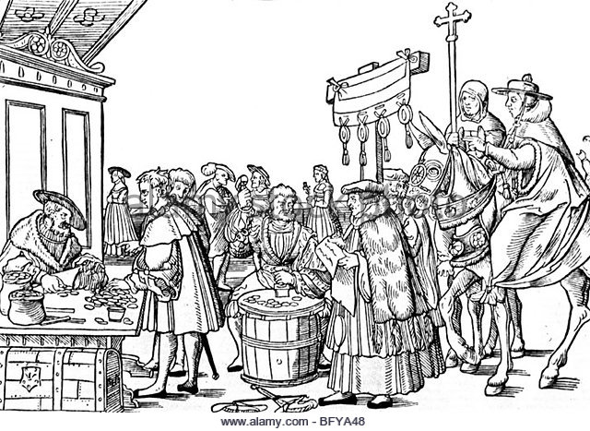
Church of England: 1500

Doc 3

Excerpt from Martin Luther King: 1517 - The grace of God be with you in all its fullness and power! Spare me, Most Reverend Father in Christ and Most Illustrious Prince, that I, the dregs of humanity, have so much boldness that I have dared to think of a letter to the height of your Sublimity. The Lord Jesus is my witness that, conscious of my smallness and baseness, I have long deferred what I am now shameless enough to do, -- moved thereto most of all by the duty of fidelity which I acknowledge that I owe to your most Reverend Fatherhood in Christ. Meanwhile, therefore, may your Highness deign to cast an eye upon one speck of dust, and for the sake of your pontifical clemency to heed my prayer. Papal indulgences for the building of St. Peter's are circulating under your most distinguished name, and as regards them, I do not bring accusation against the outcries of the preachers, which I have not heard, so much as I grieve over the wholly false impressions which the people have conceived from them; to wit, -- the unhappy souls believe that if they have purchased letters of indulgence they are sure of their salvation; again, that so soon as they cast their contributions into the money-box, souls fly out of purgatory; furthermore, that these graces [i.e., the graces conferred in the indulgences] are so great that there is no sin too great to be absolved, even, as they say -- though the thing is impossible -- if one had violated the Mother of God; again, that a man is free, through these indulgences, from all penalty and guilt.
Doc 4
Religion in Europe: 1589
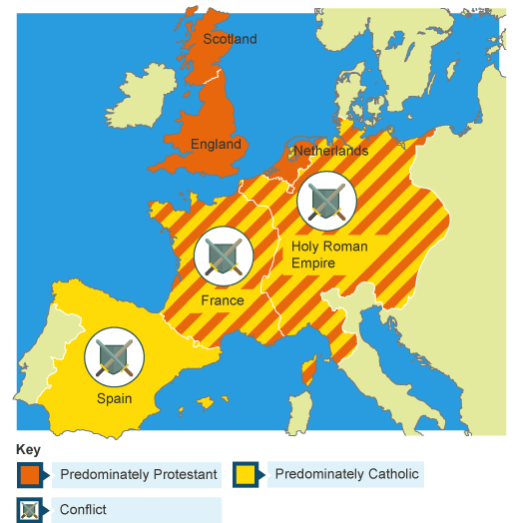

Doc 5

Excerpt from Brewster 1584: He did much good, in the country where he lived, in promoting and furthering Religion; not only by his practice and example, and provoking and encouraging of others: but by procuring good Preachers to the places thereabouts; and drawing on of others to assist and help forward in such a work, he himself most commonly deepest in the charge, and sometimes above his ability.
And in this state, he continued many years, doing the best good he could; and walking according to the light he saw, until the Lord revealed further unto him.
And, in the end, by the tyranny of the Bishops against godly Preachers and people, in silencing the one and persecuting the other; he, and many more of those times, began to look further into things; and to see into the unlawfulness of their Callings, and the burthen of many anti-Christian corruptions: which both he, and they, endeavored to cast off; as they also did, as in the beginning of this Treatise is to be seen.

Doc 6
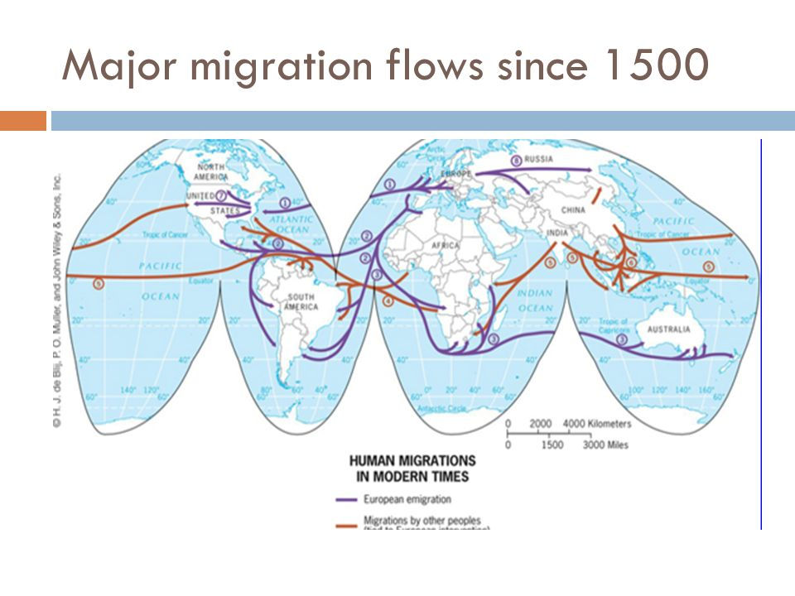
Migration patterns from 1500

Doc 7

Statement sent by Elizabeth I in the 1500s:
"There is only one Christ, Jesus, one faith, all else is a dispute over trifles."

