Delaware River Crossing
Time Period 3 Project

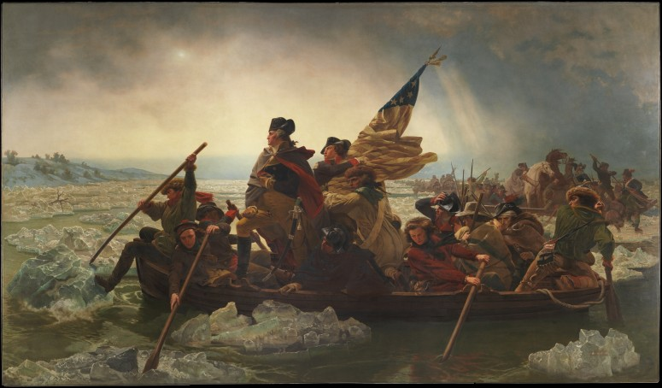
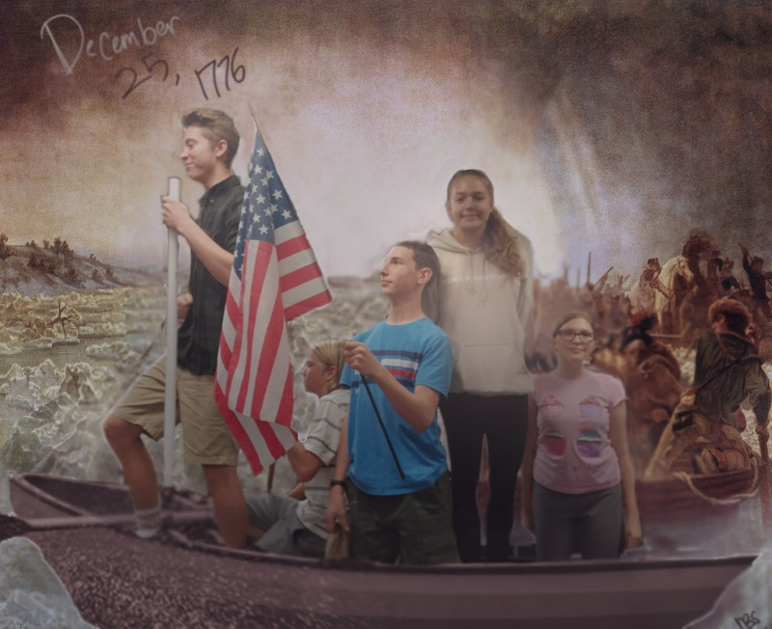

On December 1776, the famous battle that would be written in American history forever known as the Battle of Trenton occurred. In the dark of night, General Washington and his army of 4,300 men crossed the Delaware river to approach the British camp posted about nineteen miles from shore. With leading commander Colonel John Cadwalader, they ambushed the enemies forces. Although they did not win the battle, with the British forces weakened, they would sooner on win a victory on January 3, 1777 at the Battle of Princeton. This battle was a great strategical plan created in Washington’s favor, and brought him fame in our time today.

The Revolutionary War made a huge impact on the world when it happened. It showed that the 13 colonies wanted their independence from Britain and became the United States of America. They've had multiple battles with Britain, such as Lexington and Concord and Quebec. They've been through a lot. After we declared our independence, France had one of their own. Only, there's didn't go that well.

The Delaware River crossing was a significant time in history. This crossing was a significant development is strategy in war, and led to new ideas in weakening the British. Washington decided to cross this river as an element of surprise, as well as didn’t tell his soldiers the plan to keep safe. Now the reason the U.S. failed this attack was because of multiple problems. Among the soldiers was a British spy, who reported all the information he had to the British. Washington’s schedule was terribly behind, and there was a massive storm, causing only one of the three ships to make it across. This route however would eventually be used commercially, being less than 300 yards wide where Washington crossed.

