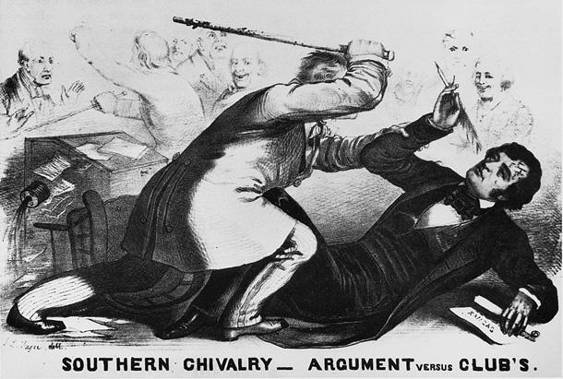

The Caning of Charles Sumner

The caning of Charles Sumner was caused when a Massachusetts abolitionist Republican addressed the Senate on the issue of whether Kansas should be admitted to the Union as a slave state or a free state. Representative Preston Brooks saw Sumner to be a rude unworthy man, so rather than challenge him to a duel, he took a cane used to discipline dogs and smacked Sumner in the head while he was working on his “Crime Against Kansas” speech. Brooks freely walked out of the halls of Congress.

The attack of Charles Sumner was used by the abolitionists as a way to attack the South. The cruel actions displayed by Preston Brooks was related to the actions of all slave owners, and gave the abolition fuel for an argumentation against the South. This pushed on the tensions between the two sections of the country, and would eventually contribute to the total succession of the South from the Union. This was a form a propaganda to further prevent help from Europe. This was greatly significant because it brought the violence of slavery from the nation into the halls of congress.

After the Civil War, the U.S. has been different. We've had our split on different topics since then and the people in the South have complete “out-of-the-box” ideas as of how they want the world. Back in the 1800’s, the South wanted to have slavery. But now, the South wants violence (the use of guns), fracking (not good), and killing of animals (for profit). I haven't seen us come together and try to get rid of these topics recently, but I know that it'll happen in due time.

